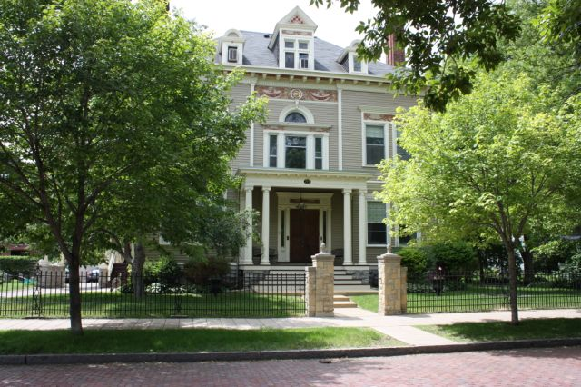

Amy Johnson Residence
January and February 2017

Newsreporter XXX111
Number 1

Thank You Friends

We want to thank C.K. for the sweet gift and generous gift that we all enjoyed, Jackie and Ron Dexter for their donations, Pierre Albrecht for the donation to Honduras.

Activities

We continue with two daily exercise groups. Our exercise DVD titled Walk Away the Pounds with Leslie Sansone is still very popular. This DVD has a great warm up and uses movements as if you were holding a ball in each hand. Whether you use a weight or not you feel this work for your arms and helps in ones balance. It feels good to keep our bodies moving and healthy. Our exercisers and walkers or swimmers are, Luanne, Steve, Patricia, Brian, Dan Z., Joan, Rick, Carla, Peggy, Marilyn, Cheryl, Rose, Dan J., Lucille, Rosanne, Tim, Mike, Kathleen and Johanna. At the end of the week, our exercisers are rewarded with a cool bottle of water. We are committed to staying healthy.

We are still enjoying playing a variety of things through Youtube onto the TV. Dan Z. has lately been picking some J Geils or Minnesota's own Lamont Cranston for music appreciation. Luanne: Van Morrison's, "Into the mystic". Kathleen is still enjoying the Bee Gees, Lucille: Barry White or Marvin Gaye. Wanda picks one of her favorite musicals: Sound of Music or Carousel. Mike still requests what he calls" the usual": John Lennon's, "Imagine" and Dylan's, "Knocking on Heavens Door". Steve: Survivor. Carla: George Harrison's, "Sweet Lord", Tim: Earth Wind and Fire Peg: Lion King's, "Can You Feel The Love Tonight". Patricia: Carly Simon and James Taylor, singing Mockingbird. Sam: Stevie Ray Vaughan, "Crossfire". Johanna: Soft Cell's "Tainted Love". Brian: Carly Simon, "You're So Vain", Lee: Victor Borge. Rosanne: Prince, and Joan: Helen Reddy's, "I Am Woman".

Jovial January

Dan Z. chose a favorite among the house, The Great Moon. Patricia, Brian, Luanne, Tim and Kathleen celebrated with him.
For Rosanne's birthday she chose Baker's Square. Ronnie, Wanda, Joan, Mike and Carla went to this Hyland Park restaurant.
Patty, our end of January baby, picked Pizza Ranch. Cheryl, Marilyn and Lucille went to this Maplewood location.

Library lovers for this edition were Marilyn, Rick, Ronnie, Tim, Luanne, Patricia, Lee and Rosanne. We have been going once a week for our movie viewers, music listeners and book readers.
Kathleen, Patty, Ronnie and Joan caught a big fish on Friday! This fish was over 22 feet long and took 3 boys 350 hours to reel him to land!

On a cold and blustery day it is fun to enjoy popcorn and a movie in one's own living room. Zootopia was enjoyed by Luanne, Patricia, Joan, Carla, Peg, Ronnie, Sam, Lucille, Patty, Wanda, Kathleen, Rosanne, Johanna and Dan Z.

A nice January escape to Como's Conservatory is always a treat. How pleasant it is to see color and flowers and greenery everywhere. Tim, Ronnie, Kathleen and Johanna went on this mini get away from winter.

Once a week we have some game options. Trivia, Hangman, Yahtzee to name some. Brian is especially good at sports trivia and Ronnie, Kathleen, Dan Z and Tim seem to remember the music and movie facts. Our gaming participants are Brian, Carla, Peg, Dan J., Lee, Ronnie, Lucille, Patty, Wanda, Tim, Steve, Cheryl, Kathleen, Johanna, Dan Z and Rosanne.

Our Movie Critic's Corner for January was split: The movies were Star Wars; Rogue One , Hidden Figures and at the Woodbury theater. Rogue One got a thumbs up. Hidden Figures got 2 thumbs up and Underworld; Blood Wars, received 1 ok and 1 thumbs up.

We had some bowlers visit the Midway. Rosanne, Carla, Tim, Luanne, Kathleen and Ronnie played or cheered their housemates on!

Fabulous February

We only had one February resident birthday and Joan picked The Great Moon. Celebrating with her were Rosanne, Luanne, Patricia, Lucille, Tim and Dan Z.
Peg, Patty, Kathleen, Dan Z. and Tim enjoyed mass at Church of the Assumption and Snuffy's Malt Shop after.
St. Clair Broiler was enjoyed by Marilyn, Sam, Kathleen, Mike and Brian.
Wanda, Cheryl, Patty and Steve enjoyed the Original Pancake House in Roseville. It was a new treat as no one had been there before. It was a crowd pleaser and I am sure it will be repeated.

Valentine's Day was enjoyed by Valentine puzzles, Trivia and decorating cookies. On Cupid's day proper Valentines were exchanged.
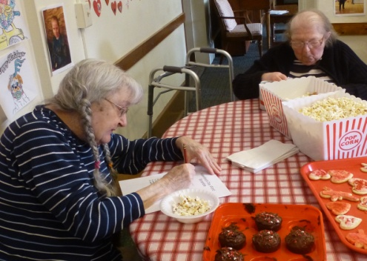
Our Movie Critic's Corner for February was split: The movies were Lion and Hidden Figures at the Woodbury theater. Lion got 2 thumbs up and Hidden Figures got 3 thumbs up. Dan Z., Luanne, Kathleen, Tim and Patricia were our movie goers.

Our Sunday Bingo players for January and February were Joan, Ronnie, Marilyn, Rosanne, Patty, Tim, Kathleen, Johanna, and Dan Z.

January and February MCD coffee or soda partipants were, Luanne, Patricia, Brian, Joan, Carla, Sam, Marilyn, Lucille, Lee, Patty, Wanda, Tim, Kathleen, Ronnie, Peg, Johanna and Dan Z. No matter what franchise we go to this is a favorite. Always nice to chat about this or that in a smaller group setting.

January and February shoppers and errand participants may have gone to the following: Target, Dollar Tree, Great Clips, Pearle Vision, Walmart, Thrift Stores, Post Office, Walgreens, Kohls and Goodwill . Some of those that went were Luanne, Steve, Patricia, Joan, Rosanne, Lucille, Carla, Lee, Peg, Patty, Tim, Kathleen, Brian, Marilyn, Wanda, Johanna, Ronnie, Cheryl and Dan Z.
Inspirational Thought

The interior joy we feel when we have done a good deed, when we feel we have been needed somewhere and have lent a helping hand, is the nourishment the soul requires. Without those times when we feel to be part of the spiritual word by our actions, our soul decays. (Albert Schweitzer)

Environmental News

Reduce purchases - In general, think before you buy any product - do you really need it? How did the production of this product impact the environment and what further impacts will there be with the disposal of the product (and associated packaging materials)? When you are thinking about buying something, try the 30-Day Rule -- wait 30 days after the first time you decide you want a product to really make your decision. This will eliminate impulse buying.

News from Honduras

"We received your check on Friday. On Saturday , we paid for the gifts of the Samaritan's purse which will be given to children in four communities. I came back to Tegucigalpa yesterday. Thank you so much for the support for this project. The celebration of the activities will be next week. My family are fine and they send you lots of hugs. God bless you! " Deysi Blanco (sent Jan 31)(The Samaritan purses include a gift of clothing, school supplies and a child's gift)

Happy Birthdays
January 5 - Dan Zieman is a veteran and tells of his interesting service experiences. He used to play the guitar with a music group.
5 - Devonna Tombers (staff - PD HCC)
18 - Rosanne Tuma is very artistic and likes to create pictures. She also has a job that keeps her busy.
27 - Kristi Yang (staff TMA)
31 - Patty Metty is our seamstress and quilt maker. She is also a whiz at Sudoku and other puzzles.
February 4 - Dan Wilkes (staff - maintenance)
5 - Joan Gallas attends interesting day programs, She likes to make different things and regularly attends Bible study.
24 - Angela Philipp (staff - RN)
26 - Sanya Parker (staff - cook)

Roaming Reporter wants to know...

What is your favorite memory of winter?

Mike- Playing hockey
Cheryl- Playing hockey
Rosanne- Skiing
Wanda- Ice skating
Rose- Christmas in Wisconsin
Carla- Going to McDonalds
Kathleen- Sledding and then having hot chocolate
Tim- Mystery rides
Dan Z.- Ice skating
Peg- Going tobogganing and ice skating
Joan- Snow ball fights
Brian- Delivering newspapers Christmas Eve.
Ronnie- See lights on houses and trees
Steve- When it snowed
Johanna- Seeing the snow stick to the trees
Lucille- Walking down to Nina's
Patty- Seeing the ice castle in downtown St. Paul

