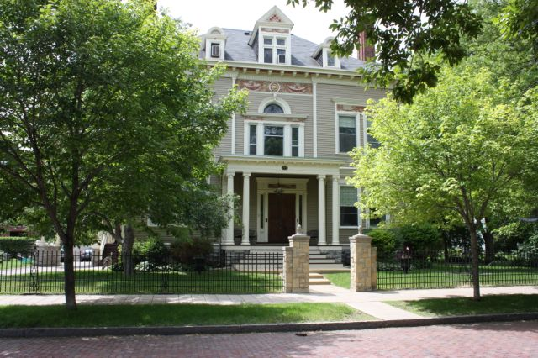

Amy Johnson Residence
July and August 2017

Newsreporter XXX111
Number 4

Thank You Friends

We appreciate the caring and gifts that we receive from so many. Thanks to Kathy Kenyon, Kateri, Tony and Sandy Menke, and Josie Daley.

Ecstatic Exercisers

In our commitment to staying healthy, we continue breaking into two exercise groups every day. Some choose a DVD entitled Walk Away The Pounds with Leslie Sansome. The routine in the DVD has a great warm-up exercise that uses movement as if you were holding a ball in each hand. There is the option to use a weight, but either way the work-out can be felt in the arms and legs and helps with balance. Our exercisers and walkers or swimmers are: Luanne, Steve, Patricia, Brian, Joan, Rick, Peggy, Marilyn, Cheryl, Rose, Tim, Mike, Kathleen, Johanna and Dan Z. Our exercisers are rewarded with a cool bottle of water at the end of each week.

Better then MTV

We have added a twist to a favorite morning activity known as music appreciation. The last couple months we picked a theme to be inspired by, but this time around the challenge was to come up with a song that may have the word "sun", "blue", or "girl" in the title or lyrics. Our group was up for the challenge. Here are just some of the titles we came up with: "Here Comes the Sun" by the Beatles; "My Girl" by The Temptations; "Blue Hawaii" from Elvis Presley; "Girl You'll Be A Woman Soon" by Neil Diamond. Another from Neil Diamond, "Song Sung Blue"; "Don't It Make My Brown Eyes Blue", by Crystal Gayle; "Bluer Than Blue" by Michael Johnson. "Blues Power", Eric Clapton"; Blue Velvet" by Bobby Vinton; and "Seasons in the Sun" by Terry Jacks. Sam came up with "Seven Sojourn" by The Moody Blues. Peg wanted to hear " Lift High the Cross". "Yeah!" by Usher was a requested by Kathleen. One of Patty's requests was "Hometown Glory" by Adele. Wanda can never get enough of " If I Loved You" from the movie Carousel. Joan picked Elton John's "Levon". Tim: "Landslide" by Fleetwood Mac. Carla: George Harrison's "Sweet Lord"; John and Yoko's "Ballad of John and Yoko." Steve chose "Beast of Burden" by The Rolling Stones. Johanna: " Tainted Love" from Soft Cell. Luanne: " Brown Eyed Girl" by Van Morrison. Rose chose James Taylor and Carly Simon singing "Mockingbird." Ronnie wanted to hear Carrie Underwood's "Something in the Water". Dan Z.: "Hot Legs" by Rod Stewart. Dan J.: "Hush" from Deep Purple. Rick brought on The Doors "L.A. Woman." "Jailhouse Rock" by Elvis Presley was a request from Cheryl. Mike trades off from his usual: John Lennon, "Imagine", and The Beatles, "Let it Be", or Bob Dylan's "Knocking on Heaven's Door." Lucille picked Barbara Streisand singing, "Funny Girl". It's fun to hear the all the different kinds of music that our group enjoys.

Activities

We enjoy reminiscing about school days, favorite subjects and teachers. We like to go through the alphabet and name food, animals, children’s names and occupations starting with each letter. Sometimes, we each take a volume of our nature encyclopedia and tell about some animal or insect that is listed in the book we chose. We do the same with the set of books telling of each country. We choose something interesting about our country and tell the others about it.
In Bible study, we are learning about the many teachings of Jesus. Since we are a diversified group, we like sharing our various thoughts and interpretations of the Bible stories. We’re good at quizzes of all kinds. In our "What’s Up?" sessions, we share what we have been doing over the past week.

Jazzy July

We started out the month with a festive 4th of July party. The dining room was decked out with red, white and blue! Luanne, Steve, Patricia, Brian, Joan, Marilyn, Ronnie, Cheryl, Patty, Wanda, Tim, Kathleen, Johanna, and Dan Z all enjoyed this patriotic party. Laura did a "bang" up meal!

We had two July birthdays. Patricia picked out Ol' Mexico. Wanda and Kathleen celebrated with her. Dan J. chose a picnic lunch, eating Culvers at Newell Park. Dan Z. and Tim enjoyed a beautiful day to celebrate a birthday outside! The 3rd food outing that was drawn was The Great Moon. Luanne, Joan, Cheryl, Lucille, Patty, Tim and Dan Z. enjoyed this favorite on Robert St.

We had a Mystery Ride and the destination was Lake Harriet. Those brave enough to go on the unknown ride at the time were Kathleen, Luanne, Joan, Ronnie and Patty.

Our Movie Critic's Corner for July was a split theater experience. Kathleen and Luanne saw the comedy, The House. They gave it a thumbs up and a thumbs down. Tim and Dan Z. saw Spider Man: Homecoming. They gave it 2 thumbs up!

Library lovers for this edition were Marilyn, Rick, Ronnie, Tim, Sam, Kathleen and Joan. We have been going once a week for our movie viewers, music listeners and book readers or those who would just like to go for the ride.
Active August

We enjoyed our fishing trip with the organization Let's Go Fishing in June so much we went on another in August. This time we boarded in Prescott to see that end of the St. Croix. We had a lovely picnic lunch along the water before we crossed into Wisconsin. Luanne, Patty, Sam, Tim, Patricia, Ronnie and Kathleen enjoyed this scenic pontoon ride and fishing. Sam and Ronnie caught Sunfish this time around.

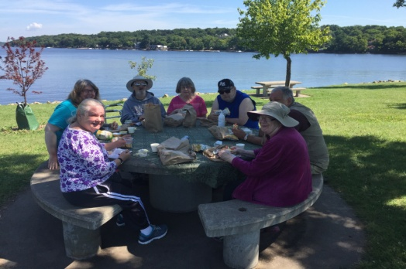

On the 21st of August, many safely witnessed the solar eclipse. Prior to the event we made pin hole boxes and talked about the exciting event. Kathy and her husband donated some official glasses.

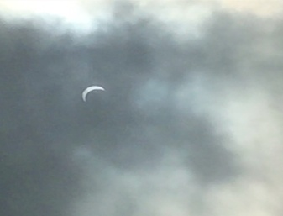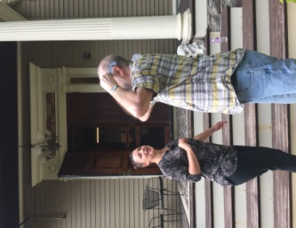
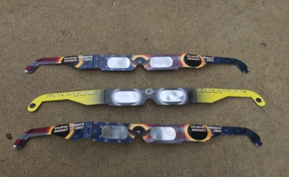
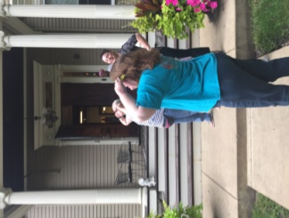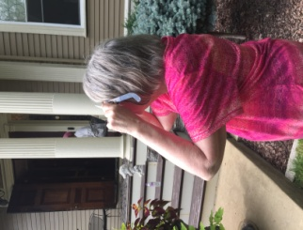

Our movies critic's corner for August was Logan Lucky. Patricia, Kathleen, Tim, Dan Z., Luanne and Joan saw this film. This movie received 6 thumbs up!

We did not have any August birthdays so The Great Moon and The Golden Corral were our restaurant outings for the month. Great Moon was enjoyed by Dan Z., Joan, Johanna, Luanne, Cheryl, Patricia, Lucille, Patty, Marilyn and Sam. Golden Corral visitors were Carla, Brian, Kathleen,Tim, Wanda, and Mike.

Thank you to Kathy Kenyon for having us over to her house for a wonderful social hour. We loaded up in small groups for three rides to Bloomington. We had cameo visits from her husband Dale and her daughter in law Kateri and charming cat Pedro. We had such a nice drive and chat time at her lovely home. Those that attended were Mike, Carla, Brian, Tim, Kathleen, Peg, Dan Z., Luanne, Steve, Patricia, Joan, Rick, Marilyn, Cheryl, Lucille, Patty, Wanda and Johanna.

To end the summer properly, we made a trip to the State Fair. Those who went with us as a group or with friends or family to "The Great Minnesota Get-Together" were Marilyn, Dan Z., Kathleen, Joan, Cheryl, Mike and Patty. Kathleen and Dan Z. went on the tallest traveling ferris wheel. It is 15 stories high. We visted the Education, Dairy and Horticultual, and Creative Arts buildings. We saw goats, cows, pigs, horses, chickens, ducks, sheep and llamas. Everyone got to sample and see everything they wanted and then some!

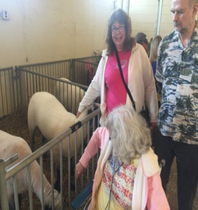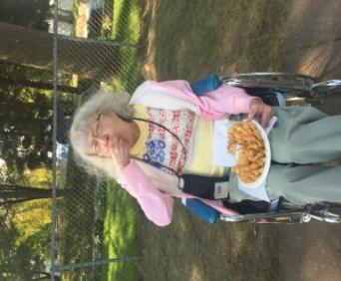
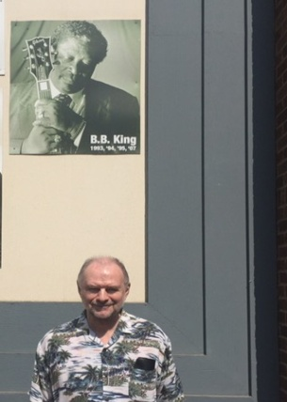

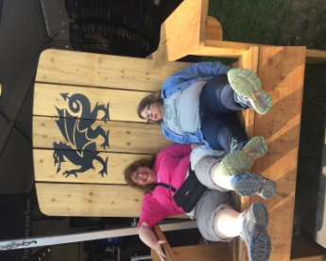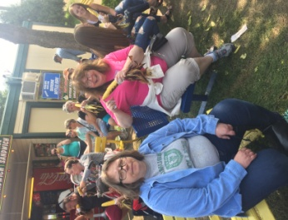

We received some apples from Ted Johnson's farm. Many were able to enjoy the Zestar Apples at snack.

Our Sunday Bingo players for July and August were Dan Z., Ronnie, Johanna, Lucille, Kathleen, Patty, Marilyn, Dan J. and Joan.

It is always nice to get together in smaller groups and take about this and that. Most of

July and August coffee or soda outings were to the MCD on West 7. Partipants were, Patricia, Luanne, Rick, Tim, Patty, Peg, Kathleen, Brian, Joan, Mike, Marilyn, Ronnie, Sam, Lucille, Carla, Wanda, Johanna and Dan Z.
July and August shoppers and errand participants may have gone to the following: Target, Pusch Salon, Dollar Tree, Great Clips, Pearle Vision, Walmart, Family Dollar, Cheapo's, Good Will, Post Office, St. Patrick's Guild and Walgreens. Some of those that went were Luanne, Steve, Patricia, Joan, Lucille, Peg, Patty, Tim, Kathleen, Brian, Marilyn, Sam, Wanda, Mike, Johanna, Ronnie and Dan Z.

Inspirational Thought

“When I admire the wonders of a sunset or the beauty of the moon, my soul expands in the worship of the creator."
"You must be the change you wish to see in the world."
(Mahatma Gandhi)

Environmental News

Buy food (and drink - ideally tap water) from local companies whenever possible. Each pound of local food you purchase prevents a quarter pound of climate change (CO2) emissions. Support your area’s Farmer’s Market and community supported agriculture. Look for restaurants that cook with regional cuisine.

Happy Birthdays

July 2 - Dan Jagiello is a fine fisherman and nature lover. He enjoys going out with his brother often.
3 - Patricia DaSilva likes to get out on frequent walks. Chatting on her phone is fun too.
15 - Laura Nelson (Staff - Cook)
19 - Mary Kaye Bagge (Staff - Business Office Manager)
August 1- Kathy Kenyon (Staff- Activities)

News From Honduras

How are you? We send you blessing hoping you are fine. We are working a lot at the villages. We will have celebrations next month because The Children's Day will be on September 10. We thank you for helping us for these celebrations. We pray for you and your family. God have you in good health. God BLESS YOU.

Residents Corner

A Wedding

A sign among the trees so green,
A lovely summer so great to see,
only a bird along the road,
a summer breezes with no bees and sing
along the trees,
The sun felt so bright.
Love never ending and beauty across
the water on a lake meeting more folks.
A blue and yellow awning brightens
and shades of summer grass.
I saw a kiss and they were wed and gone.
The sun goes down among a blue fish among a tattered sign.
A lovely summer so great to see.

By Lucille McCain

The Roaming Reporter Wants To Know...

What was one of your favorite activities this summer?

Tim- Going on a picnic and taking a pontoon ride on the St. Croix

Brian- Going to Red Savoy

Lucille- Having a picnic and then the boat ride

Peg- Going to the Dollar Store and getting greeting cards

Patricia- Going to the movies

Kathleen- Let's go Fishing adventures and having a picnic before and going to the State Fair

Johanna- Going on a picnic at Cherokee Park

Dan Z.- Going to the State Fair

Joan- Going to the Goodwill

Wanda- Going to restaurants

Marilyn- Going to restaurants and MCD

Cheryl- Going to the zoo

Luanne- Walking and drawing

Ronnie- Going fishing

Rick- Music appreciation in the morning

Carla- Going to MCD

