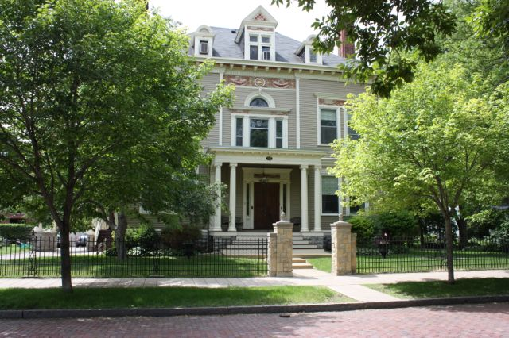

Amy Johnson Residence
July and August 2016

Newsreporter XXX11
Number 4

Thank You Friends
A WORD OF APPRECIATION FOR THE KINDNESSES OF MANY

Our sincere gratitude for the caring folks who share with us - Ron and Jackie Dexter, Tom Scott and family, the Jaycees, Mrs. Pierrette Albrecht, "Let's go Fishing" crew, Santa Bob and Doug, Lois and Bud Burnes, Marilyn Allen and Nancy Allen. Gail Anderson for State Fair tickets.

Activities

In July we sang lots of patriotic songs and talked about the history of our country. It's been fun talking about vacations and the various states and countries that we have visited. In using our nature encyclopedias, we made reports on various animals that especially interested us in nature. We try to read a play every so often, so each person has an opportunity to be a budding actor! We made yummy no bake cookies which we had during snack time. We also liked making "gorp" trail mix. In Bible study we have talked about the life of Jesus and also how sorrow and loss affects our lives. We share ideas of life experiences and how we can help one another. In Community meeting, we get caught up on each of our activities over the weekend and other happenings. At our month's Resident Council meetings, we discuss anything special on our minds and make suggestions to continue to make our community a fine one.

We continue with two daily exercise groups. Some chose a DVD titled Walk Away the Pounds with Leslie Sansone. This DVD has a great warm up and uses movements like as if you were holding a ball in each hand. Whether you use a weight or not you feel this work for your arms. Some walk outside in our beautiful neighborhood. Either way it feels good to keep our bodies moving and healthy.

Music appreciation is still taking place many mornings before lunch. Dan Z. has lately been picking some Muddy Water or Lonnie Mack, Luanne: Van Morrison, Kathleen: Bee Gees, Lucille: Barry White or Barbara Streisand, Wanda picks one of her favorites from the musical Oklahoma. Mike never tires of Beatles and Dylan. Steve: Duran Duran or Molly Hatchet. Carla: George Harrison or Tommy James and the Shondells, Tim: Minnie Riperton, Peg picks Sandi Patty or Il Divo. Patricia: Willie Nelson, Sam: Stevie Ray Vaughan Johanna: Beatles or Moody Blues. Brian: Sam Cooke and anyone singing, "What A Wonderful World", Joan: Elton John, Ronnie: Carrie Underwood, Patti: Adele, Lee: Shirley Bassey and Dan J.: Deep Purple. This continues to be a fun late morning ritual!

I would like to introduce our new resident Ronnie. He loves animals, music, to go fishing, movies and to go on adventures. He is an avid sports fanatic. His favorite teams are the Vikings, the Wild and the Twins. He has a great sense of humor and is a delightful addition!

Jazzy July

To start out the month Duane and friends played and sang patriotic songs for us on the holiday weekend.

We had a lovely adventure with the organization Let's Go Fishing. We started with a bagged lunch at a picnic table overlooking the St. Croix. It was enjoyable to watch the boats go by. It was a covered pontoon equipped with fishing rods for those who wanted to fish. Captain Dave and his lovely assistant Peggy pointed out parts of the boat. Our crew members were Steve, Kathleen, Patty, Patricia, Lucille, and Mike. Patty, Kathleen and Steve went fishing. Patty caught what we believe was a small mouthed bass. We saw eagles, egrets, herons, and saw how much they had gotten done on the bridge that is in Stillwater and crosses to the Wisconsin side. The pontoon ride on the St. Croix was so relaxing.
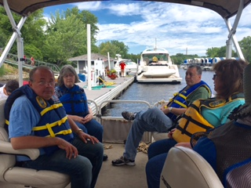
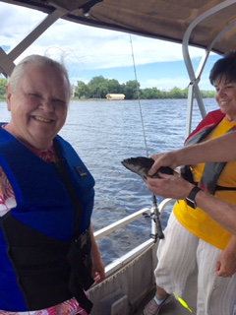
The Jaycees visited us. We had a fun game of card Bingo. It was a great way to play where one did not need markers. Steve, Carla, Patricia and Diane received prizes. After that we enjoyed ice cream and chatting about what we have done this summer and look forward to doing. Luke who is 8 played the piano for us. It was a delightful afternoon. Thank you Jaycees!
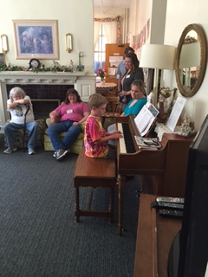
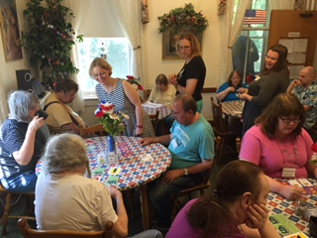

Patricia picked out Great Moon for her birthday lunch. Those attending with her were Luanne, Joan, Dan Z., Kathleen, Cheryl and Patty. Dan J. picked a lovely park where we had Culvers with beautiful scenery. Peg
joined us and then we had DQ for dessert.
The other two food outings were Red Lobster where our seafood lovers Marilyn, Sam, Steve and Lucille enjoyed. Old Country Buffet was savored by Brian, Carla, Wanda and Mike.

A great place that is appreciated by everyone is the Raptor Center. Kathleen, Tim, Dan Z., Steve, Joan, Patty and Carla took part in this great place. We learn so much when we go there. We learned why the turkey vulture head is bald. It is so they don't get messy when enjoying the roadside dining. Also gas utility companies scent natural gas with the same odor emitted by dead animals, intentionally using the presence of turkey vultures as a means of identifying gas leaks in underground pipes. The peregrines are the fastest animal in the world. When they catch their prey on the fly they can dive at speeds of 160- 220 miles per hour. We saw those birds of prey as well as a barred owl, red tailed hawk, great horned owl, American kestrel and of course the bald eagle. At the end of our tour we got to see what our wing span would be similar too. Most of us had the wing span of a turkey vulture and a red tailed hawk.

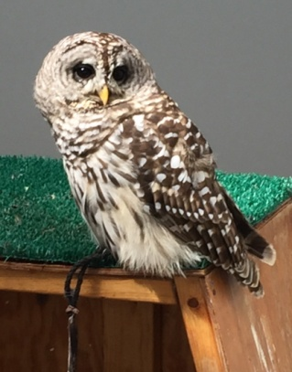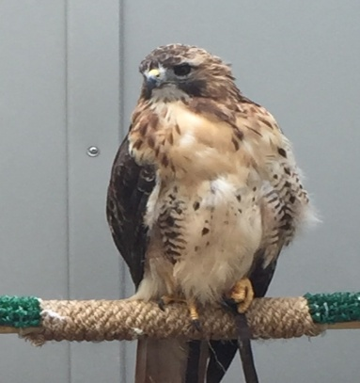
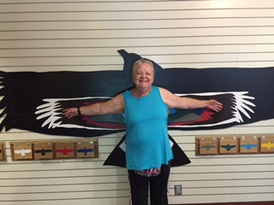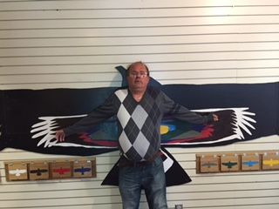
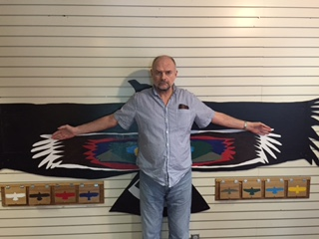

Our Movie Critic's Corner for July was Ghost Busters and Star Trek Beyond. Ronnie and Patricia gave Star Trek Beyond 2 thumbs up. Tim, Kathleen, Dan Z., Luanne and Johanna saw The remake of
Ghost Busters. We got three thumbs up and two o.k.'s.
Library lovers for this edition were Marilyn, Rick, Ronnie, Tim and Kathleen.

Our mystery ride was to Minnehaha Falls: it was running full throttle. Those who braved the unknown destination were Kathleen, Peg, Brian, Joan, Carla, Diane and Johanna.
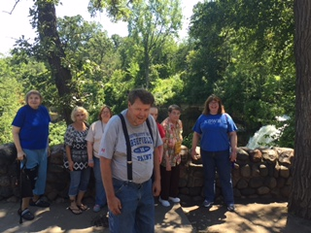

Awesome August

Since we did not have any August birthdays, three places were picked out of a hat. White Caste, Pizza Ranch (which was a first for everybody) and Cracker Barrel. Our WC Supper Club goers were Diane, Marilyn, Brian, Ronnie, Wanda and Cheryl.
Cracker Barrel was a pleasant drive. Those who drove to Lakeville to enjoy this eatery were Steve, Sam, Carla and Mike.
Pizza Ranch was a big hit shared by Patty, Lucille, Patricia, Kathleen, Dan Z., Luanne, and Joan. We all loved it and I am sure this will be on the list soon.

We had a Hawaiian Party. This summer party included pineapple, watermelon, macadamia nuts and Don Ho punch (a banana and pineapple punch) It was relaxing to have fresh fruit and listen to tropical music. Our ladies were adorned with flowers in their hair and all greeted with a lei.
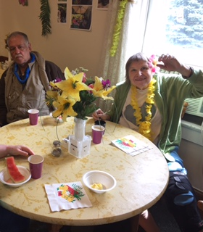
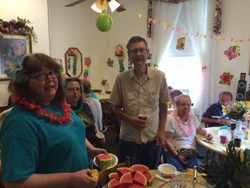
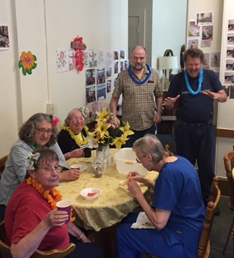
Our August mystery ride was a true mystery. It was one of those days where the weather couldn't decide to clear up or rain. Those who enjoyed driving around St. Paul through various parks and to Como were Tim, Ronnie, Carla, Kathleen, and Dan Z.

Our August movie crictic's corner was split: The movies were Jason Bourne and Nine Lives. The crew that saw Jason Bourne were Dan Z., Kathleen, Luanne, Patricia and Lucille. Those that saw the action packed thriller gave it five thumbs up. Nine Lives was enjoyed by Ronnie and Johanna which gave it two thumbs up. 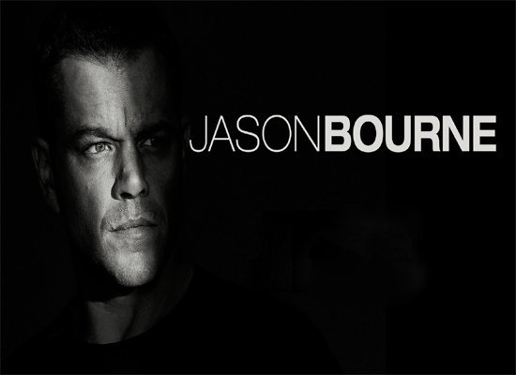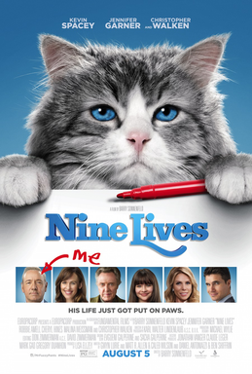

To end the month of August was a trip to the State Fair. Some residents went with family and friends and some went as a group as an activity. Those that went were Ronnie, Kathleen, Dan Z., Marilyn and Joan. Marilyn was map queen. Prior to the day it was discussed what was to be seen or consumed. We made it to the Miricle of Birth Barn. The DNR Building, Dairy Building, International Bazar, Creative Arts Building, Educational and the Horticultural Building. We had a perfect day for our visit to "The Great
Minnesota Get Together!"
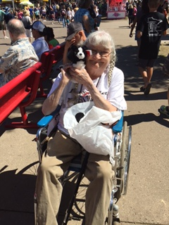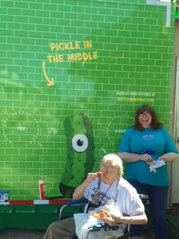
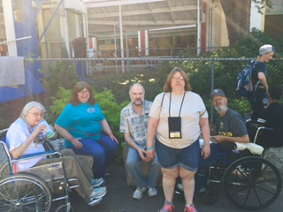

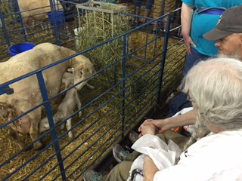

This was in the Horticultural Building: you would look through the kaledescope and then you would see an image like to the right. They had four different arrangements to look through the looking glass.

July and August MCD coffee, tea or soda participants were Luanne, Patricia, Brian, Joan, Diane, Marilyn, Lucille, Patty, Wanda, Tim, Kathleen, Ronnie, Peg, Johanna and Dan Z.

July and August shoppers and errand participants may have gone to the following: Target, Dollar Tree, Great Clips, Pearle Vision, Post Office, Goodwill and Sears. Some of those that went were Luanne, Steve, Patricia, Joan, Diane, Carla, Peg, Patty, Tim, Kathleen, Brian, Lee, Carla, Marilyn, Rose, Wanda, Johanna, Ronnie, Dan J. and Dan Z .

Our Sunday Bingo players for May and June were Joan, Diane, Marilyn, Patty, Dan J., Tim, Lucille, Sam, Kathleen, Johanna, and Dan Z.

INSPIRATIONAL THOUGHT
". . .the more clearly we can focus our attention on the wonders
and realities of the universe about us
the less taste we shall have for the destruction of the race."
(Rachel Carson)

NEWS FROM HONDURAS

We have received appreciation from our Honduras friends for the donations we send to them to help the poor in five communities. Deysi Blanco is the minister who works in these communities in "El Sud" of Honduras. These groups are so needy and do appreciate our help. We save our pop cans and used postage stamps to earn money to send, besides our pennies in our piggy bank! It's fun to count up our donations every month.
ENVIRONMENTAL NEWS

Remember that you can recycle more than you think. Milk cartons, juice boxes and soup carton all can be recycled. Just rinse out the carton before placing it in your bin with the cap or lid on. Keep troublesome items like plastic and bags and food pouches out but look for other options like stop off containers at retailers for plastic bags.

HAPPY BIRTHDAYS

July 2 - Daniel Jagiello shares with us much about his enjoyment of fishing and knowledge of nature in our area.
July 3 - Patricia Dasilva tells of her many outings and the fun she has with her husband and other relatives.
July 15 - Laura Nelson (staff cook)
July 19 - Mary Kaye Bagge (staff business office manager)

Roaming Reporter
What do you like at the Fair?...

Rick- Walk and look around
Joan- Ice cream and pronto pup
Patricia- The Mexican food
Dan Z.- Pronto pup and a Diet Coke
Carla- Have a hot dog
Dan J.- Go to the DNR building and see the fish
Brian- Going to the Grand Stand
Patty- See the animals and the sky ride
Luanne- The art building
Peg- The animals
Tim- People watching
Lucille- People watching
Kathleen- Trying different foods and the Miracle Birth Barn
Johanna- Carmel apples
Wanda- The animals
Ronnie- Chicken on a stick
Steve- The butterfly exhibit and Tom Thumb donuts
Sam- All the milk you can drink
Mike- The french fries in a bucket and apple pie

