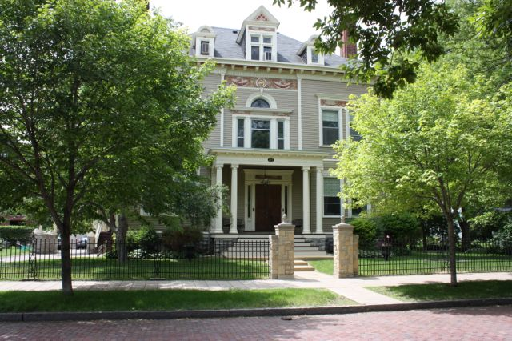
.

Amy Johnson Residence
May and June 2017

Newsreporter XXX111
Number 3

Thank You Friends

We appreciate the caring and gifts that we receive from so many. Thanks to Lee Ponander, Robyn Weich, Cindy Abraham, Barbara Harris, Bob Schaefer, Teresa Kopps Jane Grubbs, the Amons, Arlene Jullie, Cookie and Tony and Sandra Menke and Josie and Dennis Daley.

Activities

We have two exercise groups. The name of the DVD that we use is called Walk Away The Pounds with Leslie Sansone. It is a popular DVD here and it offers a great warm-up that uses movements as if you were holding a ball in each hand. One can use a weight, but even if one doesn't, the effects can be felt in one's arms and it also helps with balance. We always feel much better after we have finished our exercises and we are committed to staying healthy. Our exercisers and walkers or swimmers are, Luanne, Steve, Patricia, Brian, Dan Z., Joan, Rick, Peg, Marilyn, Ronnie, Cheryl, Rose, Dan J., Tim, Mike, Kathleen and Johanna.
We have added a twist to our morning favorite time known as music appreciation. At least once a week a theme is made. For example, during the last couple months we've created the challenge to come up with a song that may have a chosen word in the title or their lyrics, such as summer or love or heart. Sam came up with "Stone Love", by The Supremes. Peg came up with "Do You Feel the Love Tonight", from The Lion King. "Affair of the Heart" by Rick Springfield and "Silly Love Songs", by Paul McCartney is what Kathleen came up with. Patty, "A Summer Place" by Percy Faith. Tim requested "Summertime Blues" by The Who. "Dance the Night Away" by Leo Sayer was written down by a mystery requester. Lucille: Helen Reddy's "I Don't Know How to Love Him". "Here Comes the Sun" by The Beatles, requested by Mike. Wanda picked one of her favorite musicals: Carousel, "If I Loved You. " Steve: "Dance Dance Dance" by CHIC. Luanne: BB King and U2 performing "When Love Comes to Town". Picking a theme is fun and we plan to continue with this challenge. Other song choices have been Dan Z.'s picks: "Tough Enough" by The Fabulous Thunderbirds or "Hard Driving Man" by The J. Geils Band. Johanna: "Nights in White Satin". Dan J.: John Denver, "Rocking Mountain High". Patricia: "Mockingbird" by James Taylor and Carley Simon. Brian: "Things We Said Today" by The Beatles. Mike: anything from Simon and Garfunkel. Thank goodness that when you choose songs on YouTube, one does not have to know the titles; all we need to know is the artist or hum a few bars and we can find it!

Magical May

We started out the month with a Cinco de Mayo party. The dining room was decorated and mariachi music was played. Steve, Patricia, Brian, Joan, Rick, Peg, Dan J., Sam, Tim, Mike, Johanna and Dan Z. enjoyed the fiesta.

Luanne, Kathleen, Patty, and Tim checked out Mystery of the Nile at the Omni. That was a fabulous adventure to have while never leaving our town!

For our May birthdays, Tim picked DeGidios. Those celebrating this Italian eatery were, Luanne, Dan Z., Brian, Wanda and Mike.
Rick chose Cherokee Sirloin. Joan, Patty, Kathleen, Lucille and Sam celebrated Rick's birthday at this long time establishment.
Peg and her birthday companions Cheryl, Marilyn, and Patricia went to Snuffy's Malt Shop.

It wouldn't be Spring if we didn't go to Minnehaha Falls. It is nice to see it throughout the different seasons. Kathleen, Patty, Joan, Tim and Ronnie went to hear it roar.

Our Movie Critic's Corner for May was the movie Guardians of the Galaxy 2 at the Woodbury Theater. We had 5 thumbs up from Dan Z., Tim, Patricia, Joan and Kathleen. We also saw Fast and The Furious 8, The Fate of the Furious. Dan Z., Kathleen, Tim, Patricia, Joan gave it 5 thumbs up for this action fast paced movie.

The adorable Tea Cup Chihuahua visited again before they left back for out West. Steve, Patricia, Brian, Joan, Peg, Dan J. Marilyn, Rose, Sam, Lucille, Tim, Kathleen, Johanna, and Dan Z. got another chance for puppy time.

Sam, Tim, Kathleen, Rick and Johanna had a beautiful day for a picnic at Cherokee Park. After lunch we all agreed it would of been a great afternoon to be in a hammock.

Library lovers for this edition were Marilyn, Rick, Ronnie, Tim, Sam, Kathleen and Joan. We have been going once a week for our movie viewers, music listeners and book readers or those who would just like to go for the ride.

Jocund June

We had a wonderful day in St. Peter with Sam's sisters. Cheryl, Kathleen, Luanne, Peg, Tim and Patricia enjoyed this lovely drive and Josie and Dennis' hospitality.
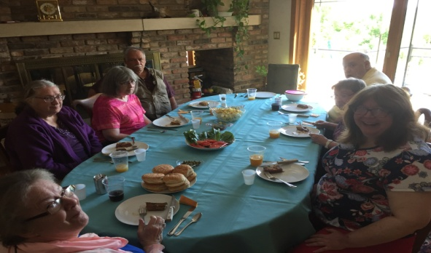

Our movies critic's corner for June was Wonder Woman, which we saw at Woodbury. Patricia, Kathleen, Tim, Dan Z., Sam and Joan saw this Justice league member. We needed no golden lasso to say it was 6 thumbs up!

What a lovely day we had for a drive and a picnic in Bayport. The cherry on top was a pontoon ride with the great organization, Let's Go Fishing. Steve, Kathleen, Sam, Ronnie and Patty did a little fishing. Tim and Lucille enjoyed the scenery and the ride. Patty was the lucky one to catch a fish.

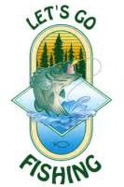

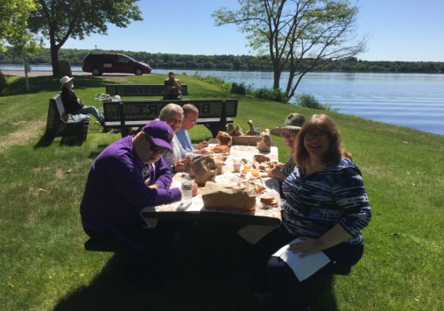

For our birthday outings this month, Sam picked The Best Steak House. Our meat lovers were Brian, Cheryl, Patty, Dan Z., Kathleen and Tim.
Ronnie picked LaCasitas. Wanda, Luanne, Patricia and Marilyn enjoyed this Mexican feast.
Our third outing was Golden Corral and those who went to this Woodbury destination were Mike, Joan and Lucille.

Before summer completely kicked in and it was actually cool out, Ronnie, Cheryl and Kathleen went to the Conservatory and Como Zoo. The Conseratory was filled with delphiums and lilies. The zoo was hopping with a show from the monkeys, giraffe, bison, penguins and lions, tigers and bears, oh my!

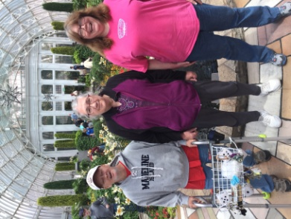

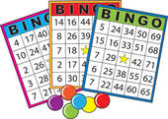
Our Sunday Bingo players for May and June were Dan Z., Ronnie, Johanna, Lucille, Kathleen, Patty, Marilyn, Dan J. and Joan.
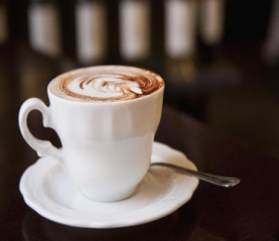

May and June coffee or soda partipants were, Patricia, Luanne, Rick, Tim, Patty, Peg, Kathleen, Brian, Joan, Mike, Marilyn, Ronnie, Sam, Lucille, Wanda, Johanna, Cheryl and Dan Z. It is always nice to get together in smaller groups too and discuss various topics.

May and June shoppers and errand participants may have gone to the following: Target, Wet Paint, Dollar Tree, Great Clips, Pearle Vision, Walmart, Family Dollar, Cheapo's, Good Will, Post Office and Walgreens . Some of those that went were Luanne, Steve, Patricia, Joan, Lucille, Peg, Patty, Tim, Kathleen, Brian, Marilyn, Sam, Wanda, Mike, Johanna, Ronnie and Dan Z.

Games we played these last couple months were hangman and flag day trivia.

Inspirational Thought

As we express our gratitude, we must never forget that the highest appreciation is not to utter words but to live by them.
(John F. Kennedy)

Environmental News

Hopefully you have already started a garden to produce your own vegetable. If you haven’t, take advantage of the local Farmers Markets which provide healthy opportunities. If you get an abundance of food from your own garden or market, be sure to share with the local food shelf or your neighbors.

Happy Birthdays

May 17 - Rick Gibbons is most interested in technology. He enjoys reading magazines, catalogs and trips to the library.
17 - Tim Quirk is an avid sports fan. He keeps up on all the scores and also is a follower of good movies and sharing their stories.
24 - Peg Igo reads a variety of books. She shares some of the inspiration that she receives and is a helpful part of Bible study.
June18 - Sam Macey keeps busy documenting important ideas and thoughts that he has. He adds information to our quiz time.
20 - Ronnie Ludgate shares his good sense of humor and some reminiscences of stories that he has read.
24 - Carla Haas has a ready smile when one chats with her. She enjoys shopping and going out to lunch.

Roaming Reporter wants to know...
If you were going on a picnic what would you bring along?

Cheryl- Iced cold pop, grill and hot dogs
Patricia- Fried chicken, corn on the cob
Kathleen- Hot dogs, cole slaw, potato salad, watermelon, baked beans and pop
Luanne- Watermelon, angel food cake with strawberries and potato salad
Sam- A radio, potato salad, Dr. Pepper
Mike- Pop, ice cream, candy, apple pie, watermelon and a table cloth
Joan- Sunglasses, sun tan lotion
Peg- Watermelon, sandwiches, bottled water
Dan Z.- Diet coke, hamburgers, baked beans
Patty- Chips, musk melon, bars, pop, hot dogs and smores makings
Lucille- Sugar free banana cream pie, pop, baked beans and chips
Johanna- Potato salad, baked beans, pop and hot dogs
Rose- Hot dog, baked beans, chips and potato salad
Wanda- Potato salad and hamburgers
Dan J.- Watermelon, hot dogs and baked beans,
Steve- Roast beef and Cheese sandwich, sweet roll, pop and potato chips

.

