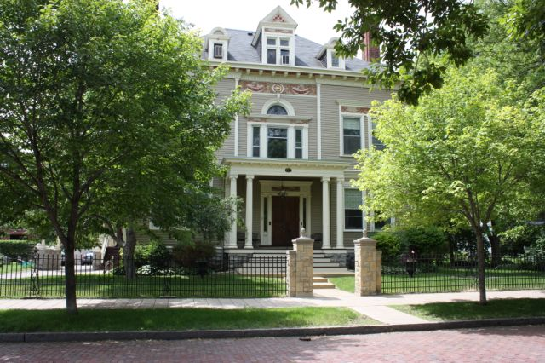

Amy Johnson Residence
March and April 2015

NewsreporterXXXI Number 2

Appreciation
We so appreciate the many acts of kindness we receive from others- donation of time and other contributions. Thanks to the following Evelyn Ludgate, Jane Grubbs, Barbara Alefeld, Dora Dickerson, Lois Burnes, Germanic American Institute, Duane Jagiello & his music group, Tania Trulson, Jackie & Ron Dexter, Captain Bob Schwartz, Officer Tad Schmidt & his dog Gabe, Kelly Robbins & her dog Scout. The St. Paul Jaycees for a fun party, songs and games!
Activities
Another enjoyable talent show was held with Wanda reading a poem about the Grand Canyon and then telling about when she visited there. Joan shared a riddle. Patty M. shared jokes and tongue twisters. Dan, Pat D, Kathy R, Kathy C and Peg gave readings. Lucille sang a song with her microphone. Afterwards, we enjoyed a spelling bee, math problems and a geography quiz. It's been fun talking about South America and studying the map. We saw pictures taken from Polynesia and South America of Kathy's trip. In our science discussion, we talked about Earth Day and what it means to us. We sang songs from "The Sound of Music" and also some hymns (following our Bible study). We wrote thank you notes to the many people who have shared their talent and treasures and stamps with us. (The stamps are cut and sold to a dealer, with the money going to our friends in Honduras).

March Adventures
In the morning we have great groups of exercisers. We have such a good turnout we have two groups. With the warmer weather we also have those that choose to walk in the lovely neighborhood.

We started out the month out with coffee at McDonalds. Those that participated in our MCD coffee runs are Katherine, Luanne, Dianna, Joan, Wanda, Kathleen, Rose S., Johanna, Michael, Tim, and Patty M. For the month of March we decorated the dining room with Leprechauns, and clovers everywhere.

We are making weekly trips to the beautiful George Latimer Library by Rice Park. Those that have come along for the library outings are Lee, Kathleen, Joan, Pat D., Patty M, Rose S., Carla and Marilyn. Some are enjoying their books, CDs and DVDs.

We saw a delightful (feel good) movie. It was based on a true story called McFarland USA. It had Kevin Costner in it. It was about a coach that moved to McFarland, CA and saw excellent potential for some high school boys to make a cross training running team. Those who went to this great film were Tim, Dan Z., Pat D., Luanne, Kathleen and Lucille. These movie critics give it a "thumbs up".

We went to the new Goodwill that opened up. It was very organized and had two levels. Joan, Kathleen, Johanna, Patty M., Dianna, and Rose S., all found a little something on that run.

Dollar Store is always a fun time. Carla, Patty M., Kathleen, and Cheryl went along.
On our lunch outing we went to Great Moon Buffet. It was delicious! Tim, Dan Z., Marilyn, Pat D., Katherine, and Rose S. went on this yummy food outing. There were so many things to try.
The Auto show at the Minneapolis Convention is here in town and Katherine, Kathleen and Patty M. were up for the event.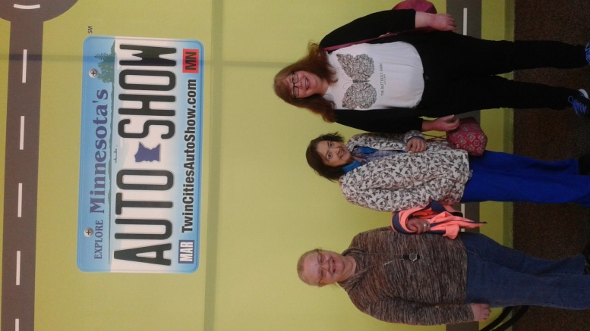 Kathleen and Patty test drive a Jeep with a professional driver to see how the vehicle handles on the different terrain.

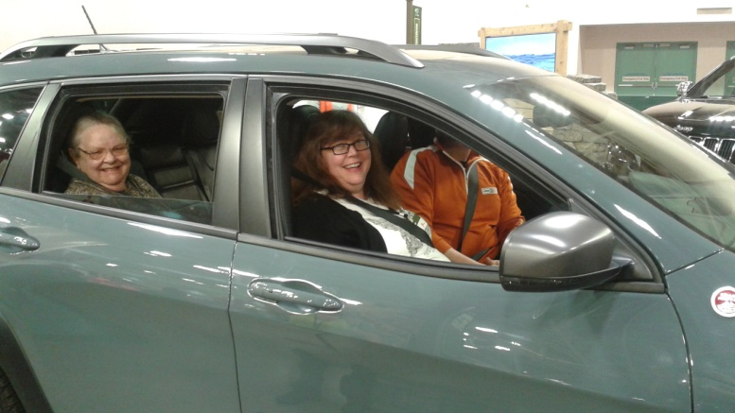 There were 450 different cars, trucks and sports utility vehicles to see. We all came home with free bags from different auto manufacturers too.

We made festive cupcakes for out St. Patrick's Day party.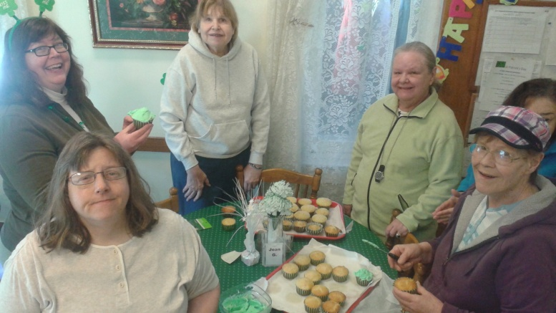 Our bakers were Dianna, Joan, Johanna, Kathleen, Katherine, Lucille, Patty M., and Rose S.
The St. Patrick's Day lunch consisted of Irish Corned Beef and Cabbage, Pot of gold carrots, O'Grady biscuits and shamrock cupcakes! 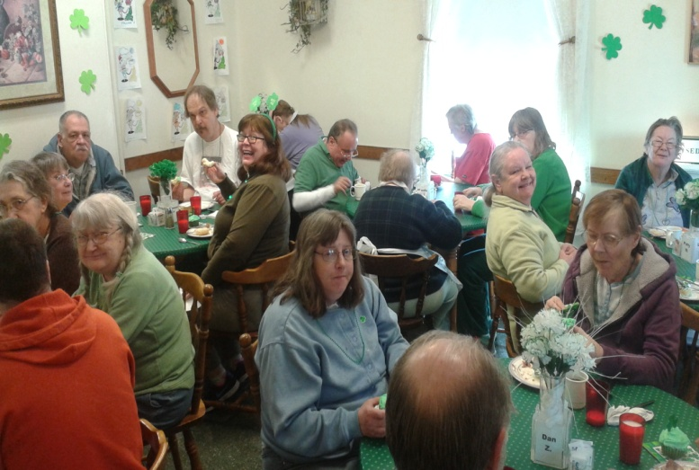

Green necklaces, Irish music and glitter tattoos were adorned by many on St. Patrick's Day.

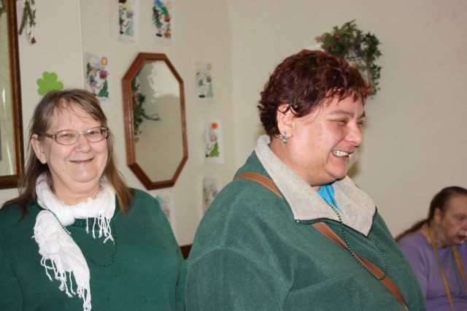

The pub was open! Green fake beer, Leprechaun fizz, peanuts in a shell and pretzels and coffee with Irish cream. 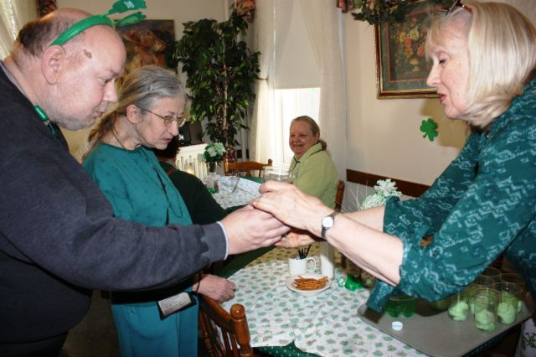 Those attending this festivity were Katherine, Steve, Pat D., Dianna, Joan, Rick, Carla, Peg, Dan J., Marilyn, Rose L., Sam, Lucille, Patty M., Wanda, Tim (he was our bartender), Mike and his friend Tom, Kathleen, Rose S., Johanna and Cheryl. Cindy (our LPN) showed us a few dancing steps. Dan J and Rose S. gave it a whirl and did fabulous!
We went to a wonderful free performance to the Sound of Music at Oak Grove Middle School in Bloomington. These talented young performers were delightful. Costumes and the set were amazing. Carla, Brian, Luanne, Pat D., Kathleen, Katherine and Joan enjoyed their talent.

The other food outing for March was DeGidio's. Brian, Luanne, Wanda, Carla, Kathleen and Patty M. went along for this Italian experience.

It was Dairy Queen's 75th birthday and there were free cones to be had! Three trips were made to take advantage of this fun edible event. Rick, Mike, Luanne, Pat D., Carla, Brian, Dianna, Joan, Lucille, Patty M., Wanda, Kathleen, Dan Z., Katherine, Tim, Rose S., Johanna and Cheryl enjoyed this treat.

Bowling was fun and great exercise. 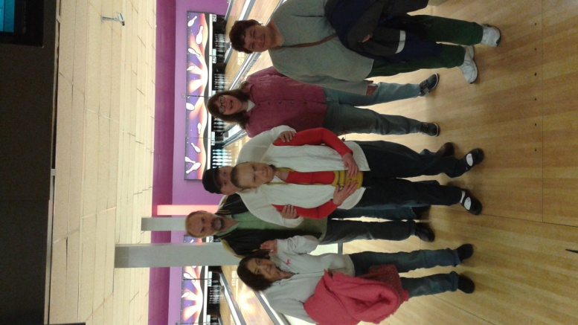 They had bumpers and a ramp for those who do not want to lift those heavy balls. 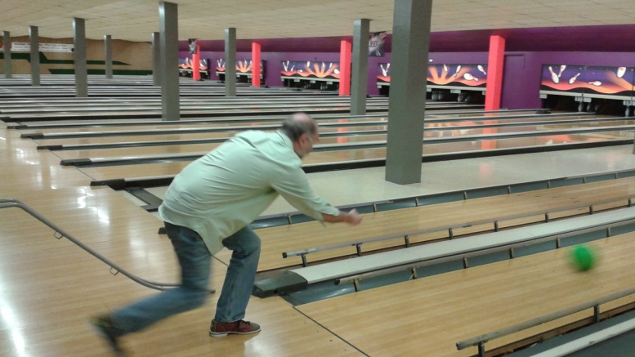AJR Bowlers were Dan Z., Tim, Kathleen, Carla, Rose and Katherine.

Now that St. Patrick's Day has come and gone we started decorating for spring and Easter. As we colored and crafted we listen to music from the IPod. Request of the Stones, Beatles, The Sound of Music and 80's music were just some of the requests. Those who enjoyed music and or art activities were Peg, Kathleen, Wanda, Rose S., Brian, Rose L., Dan Z., Katherine, Lucille, and Luanne.
We took a walk and ended up at Nina's coffee shop. Lucille, Luanne, Pat D., Kathleen, Katherine and Dianna went along for the stroll through Crocus Hill.

At T.K.s coffee it was nice to visit with Tony, the owner and hear about his cruise.

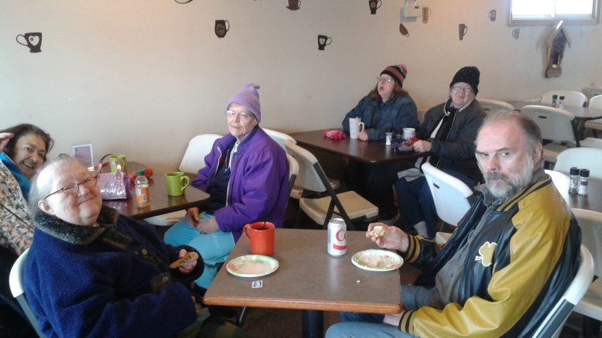 Those who went on the first round were Dan Z., Katherine, Luanne, Dianna, Wanda and Joan. 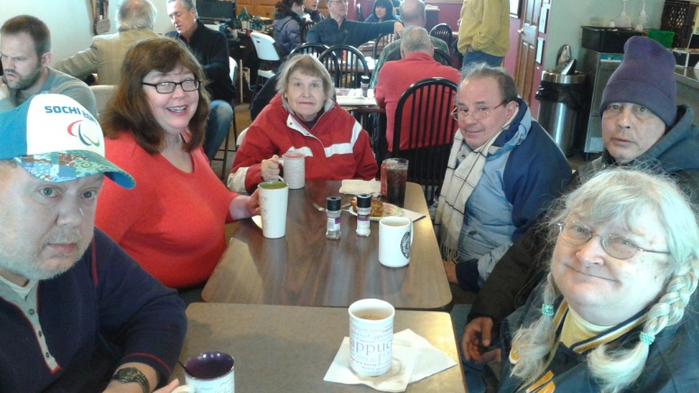
The second visit to T.K.'s included Steve, Marilyn, Lucille, Johanna, Kathleen, Mike, and Tim.
We made our last morning visit to T.K.'s. It was Pat D., Rose S., and Carla. We always have a lively conversation.

A lovely surprise visit to AJR from a past activity director Monica and her mom and friend Marla. They brought angel food cake and ice cream! It was so nice to catch up.
Kathleen, Cheryl, Dan Z., and Carla went to the Conservatory. 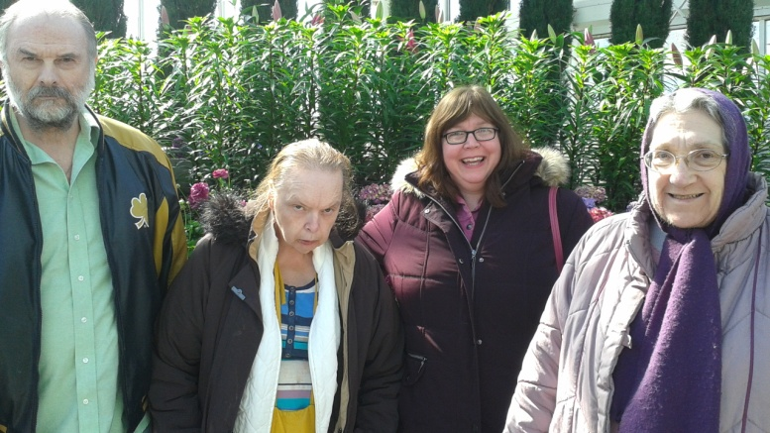 The sunken garden was nose and visual heaven. Tulips, hyacinths, freesia, lilies to name a few beauties. Then we went to the primates. The newest addition to the orangutans stole the show. She was so precious.

Our March shoppers for the month were Johanna, Kathleen, Steve, Patty, Lucille, Carla, Mike, Dianna, Joan, Rose S., Marilyn, Peg, Katherine, Pat D., Luanne, and Cheryl. Some of the stores we went to were Sears, Rosedale Mall, Dollar Tree, Target, Wal-Mart and Goodwill.

April Adventures
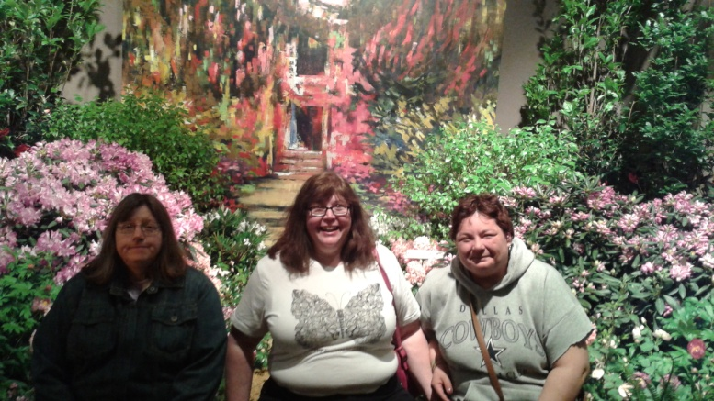
We started out the month going to the Macy's Flower show which was titled Art in Bloom.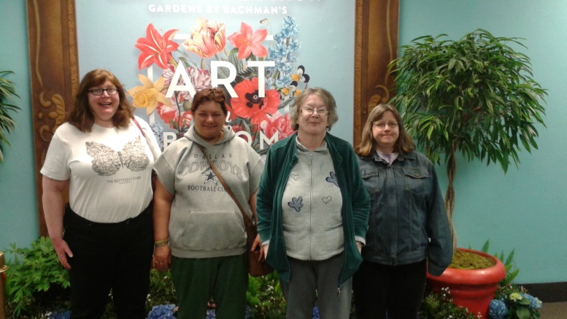 It was beautiful gardens that were surrounded with Post-Impressionist garden and Abstract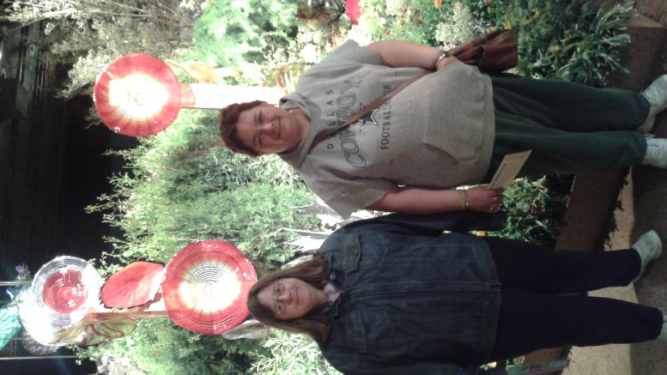 It was a visual and nose wonder. Those that participated were Kathleen, Luanne, Joan, and Rose S.

We made cupcakes. Decorating with coconut nests and jelly bean eggs. Our bakers were Brian, Dianna, Patty, Kathleen, Rose S., and Johanna. 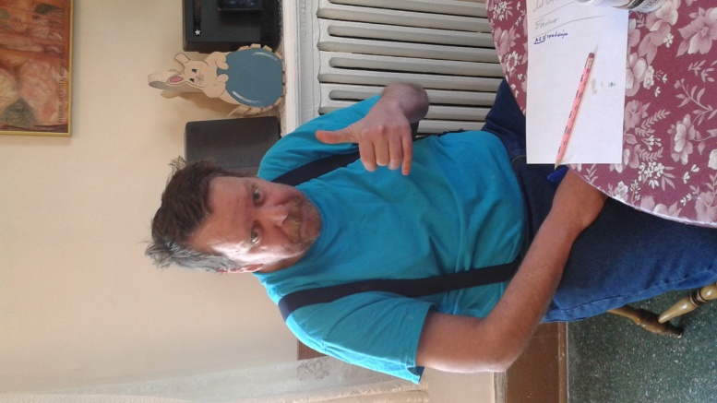Then came egg dying.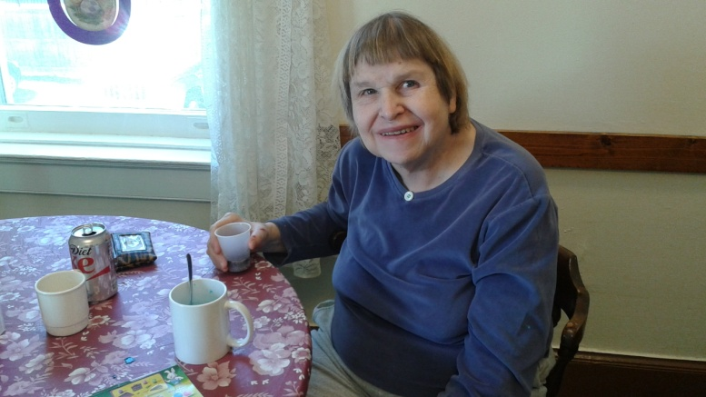
We colored and decorated 30 eggs while listening to music. Those who helped decorate were Kathleen, Patty, Lucille, Brian, Katherine, Dianna, Carla, and Johanna. Peter Rabbit hid eggs and Joan, Kathleen, Rose S., Peg, Brian, Katherine, Dianna, Carla, Cheryl, Patty, Tim and Dan Z.
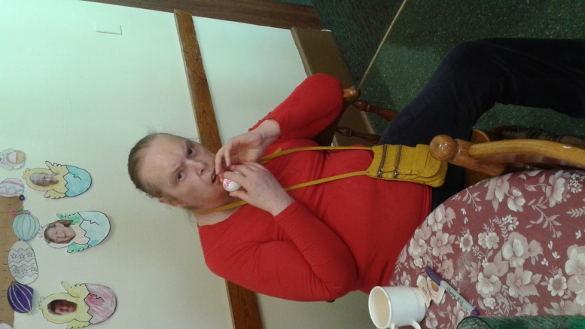 We colored and decorated 30 eggs while listening to music.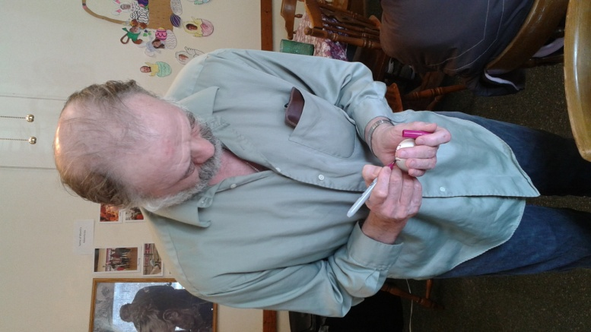
Peter Rabbit hid eggs and Joan, Kathleen, Rose S., Peg, Brian, Katherine, Dianna, Carla, Cheryl, Patty, Tim and Dan Z. Luanne, Dianna, Carla, Cheryl, Patty, and Tim, found them.
It was a wonderful Easter treat to have Dan J.'s brothers band play music for us before Easter dinner.

A Journey to Space at the Omni. Our astronauts for this trip were Marilyn, Tim, Kathleen, Rose S., Patty and Steve.

April's monthly movie was Furious 7 an action packed movie with a lot of fast and interesting vehicles. Those that went and saw this fast paced film were Luanne, Kathleen, Tim, Dan Z., Lucille and Rose S. Movie critics gave it a "thumbs up"!

A beautiful ride in 75 degree and sunny weather led us to Stillwater. We visited Leo's Grill and Malt Shop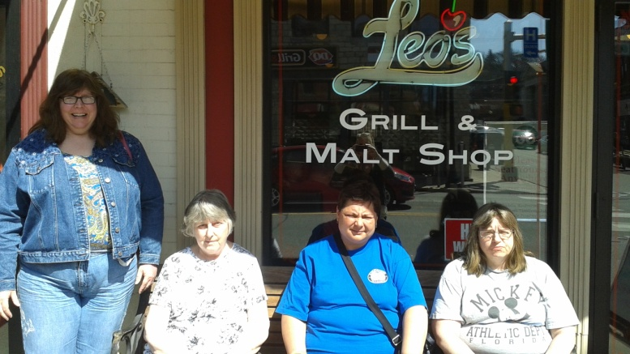 It is a 50's style restaurant with vintage signs and an old TV playing 50's cartoons. Afterwards we walked up one side of main drag and down the other side. We of course had to go down to the river. Before we headed home we crossed the bridge to say" hi" to Wisconsin.

Earth Day riddles we shared...

What did the baby LED bulb say to his mommy?
I wuv you watts and watts!
What did the ocean say to the environmentalist?
Nothing, it just waved!
If you live in an igloo, what's the worst thing about global warming?
No Privacy!

We discussed that Earth Day was originated April 22, 1970 and why we thought it was important and how it enhanced out conscious of our environment.

April 21 we had a furry visitor.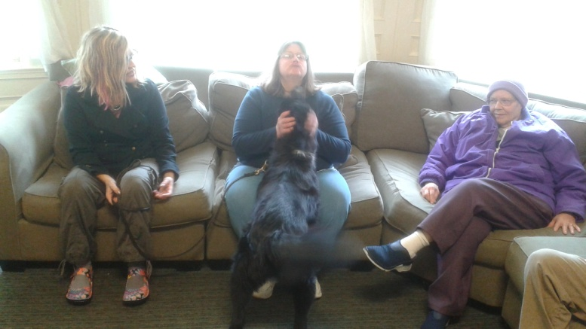 Kelly Robbins brought her 6 year old Border Collie mix, Scout. He had the softest fur.

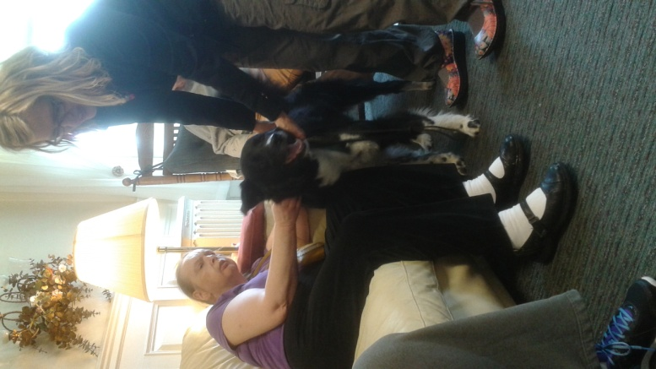 He did tricks. He sat, shook hands, rolled over and danced and hopped. We hope he will visit again.
Our April bowlers were Lucille, Kathleen, Rose S., and our high bowler Carla!
The three lunch choices for the month of April were Red Lobster, Old Country Buffet and Ol' Mexico. Since Marilyn's birthday was the 22nd, she chose Red Lobster. Those celebrating with her were Kathleen, Rose S., Steve, Lucille, Sam and Katherine. Old Country Buffet's pick was by birthday guy Mike. Those that went were Tim, Brian, Dianna, Dan Z., and Cheryl. Old Mexico was Luanne, Wanda, Carla, Patty and Pat D.

INSPIRATIONAL THOUGHT
There is just one Creation, one Nature, one good, full, complete idea, made up of individuals of all shapes and designs, all expressing their oneness with one God. We are not different because we look different, but we all reflect the eternal beauty and intelligence of one Creation in our own peculiar way. It's what makes up the whole -- this textured fabric of thought and existence... (all) underscores to me how much the same we really are. (by Deb Rivel)
NEWS FROM HONDURAS
We received the letters and the drawings from the residents. Thank you for the nice letters you sent to Honduras. We cried a lot when we read them. We are excited with the beautiful words. We appreciate every word that the residents wrote in their letters. The letter of Kathleen is very nice. She asks about our father and sent us information. I know something about the lives of many residents - Tim, Carla, Luanne, Johanna, Steve, Rose, Lucy, Lee, Dan W. Rick, Mike, Peggy, Pat M., Kathleen and Pat D. Some like to watch TV, soccer and spend time with their family. THANK YOU TO ALL OF YOU FOR YOUR WONDERFUL LETTERS AND PICTURES.
We enjoyed with the children who received the Samaritan purses (ed: gifts which we helped pay for) The children were happy and enjoyed all the gifts. We had very intense work, but thanks to God for the work we are doing in favor of those who have no voice and these are the poor children of our country. We thank you for the money you have been sending for many years for us in this ministry in Honduras. Unfortunately we do not have any economic aid or any mission or in our country for this ministry. My two sisters and my husband pay for my transportation and feeding me for the time when I am working in these villages of Choluteca. Thanks for your support. God bless you. Deysi Blanco
ENVIRONMENTAL THOUGHT
Let Earth Day be in your mind all year long! The best way to minimize food waste - and stretch the budget - is to use everything! Remember the Five Rs - refuse, reduce, reuse, recycle and rot (compost). Donate your books to the library and your clothes to a charitable organization.
HAPPY BIRTHDAYS
March 1 - Cookie McDonough (Program Director), March 26 - Jordan Haugen (Transportation Director
April 9 - Deborah Ejimofor (TMA), April 10 Cindy Abraham (LPN)
April 22 - Marilyn LaBarre, our author of many books who also likes to play the piano
April 28 - Michael Regnier, who loves walking around Lake Calhoun and also having coffee with his friend, Tom
RIDDLES OF THE MONTH
What bee can never be understood? (A bumble bee)
A giraffe, elephant, camel, bear, pig, frog, 2 mice and a snake were all sheltered under an umbrella. How many got wet?
(None, it wasn't raining)

FROM THE RESIDENT'S CORNER...
To savor a town shed and a city gone, and a bit of clay. For I've been near places on the earth. Placid a color, robin birds cluster, sun dancing and the love of nature, there is a love of the Lord, a sight of green and white almost to the heavens around every corner the bright one place. Placid Transparency of love in the theory of wonder, spring follows winter. Gone with the wind, love of the Lord, my eyes filter tears and smiles with sun lined the Earth with a bit of clay gone with the wind. Amen
Lucille Ann

