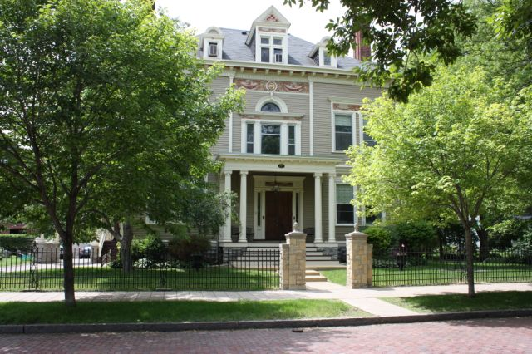

Amy Johnson Residence
September and October 2017

Newsreporter XXX111
Number 5

Thank You Friends

We are so grateful for the caring and gifts that we receive from so many. Our thanks to Jill Dan, Jane Grubbs, Jackie and Ron Dexter, Theodore King, Kirstin Cross, Barbara Alfeld, Duane Jagillo, Josie Daley, Dan and Diane Waarvik, Marilyn Allen, Tony and Sandra Menke and the Jaycees.

Ecstatic Exercisers

We continue with our daily exercise regimen. We break into two groups and some of us choose a DVD entitled Walk Away the Pounds with Leslie Sansone. This DVD features a great warm up that uses movements as if you were holding a ball in each hand. It helps us with our balance and gives us a good arm work out. It feels good to keep our bodies moving and healthy. Our exercisers and walkers or swimmers are, Luanne, Steve, Patricia, Brian, Joan, Rick, Peggy, Marilyn, Cheryl, Carla, Rose, Tim, Mike, Kathleen, Johanna and Dan Z. As a reward for our commitment to staying healthy, at the end of the week we are rewarded with a cool bottle of water.

This is some of the beautiful color we see in our neighborhood.

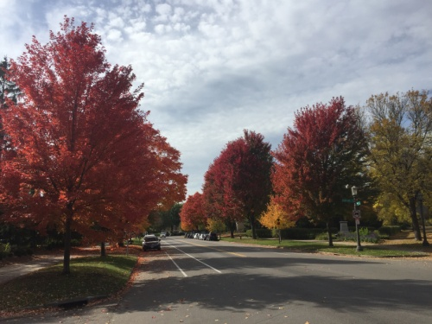

Better than MTV
A couple mornings of mornings each week we have our music appreciation, which is still a favorite. It's been fun for all of us to hear what our fellow residents like to listen to and sometimes the songs introduce us to musicians we had never heard of before or that we had forgotten. Here are some of the requests: "September" by Earth Wind and Fire, was requested by Tim. "Eve of Destruction" by Barry McGuire was Brian's choice. Dan Z. requested "Hot Legs" by Rod Stewart. Kathleen and Johanna both like the Bryan Adam's song "Run To You." Peg suggested, "Morning Has Broken", by Cats Stevens. Carla picked her all-time favorite "Sweet Lord" by George Harrison. Wanda chose the showtune "Oklahoma" from the movie Oklahoma. Patty: "The Best For Last" by Adele. "Seasons In The Sun" by Terry Jacks was requested by Joan. Johanna can't get enough of her boys The Beatles! So, we heard their famous song "Twist and Shout." Patricia loves to hear "Mockingbird" by James Taylor and Carly Simon. Mike Requested "Fire and Rain." We listened to John Denver's version. Ronnie's choice was "Jailhouse Rock" by the one and only Elvis. A song from The 5th Dimension was Cheryl's pick. Lucille wanted anything from Marvin Gaye. "Cold Shot" by Stevie Ray Vaughn was Sam's request.

Other than the joy of music, games were enjoyed: Gestures, hangman, charades and trivia were some of those that we played. Patricia, Brian, Peg, Ronnie, Joan, Lucille, Kathleen, Johanna, Patty and Dan Z., Luanne, Steve, Marilyn, Dan J., Rick and Tim participated.

Activities

We like to read plays, so it has been fun to read some old stories such as “Stone Soup” and others. We talked about books that we read when we were kids and also looked at some very old children’s books that were printed in the 1930’s. We used our science encyclopedia and each read something of interest to share with others. We also read and talked a lot about other countries and some of the interesting facts about them. We made bake - free cookies and enjoyed eating them - yum! Making fall leaves and pictures, we decorated the dining room. We have reminisced about our favorite teachers and classes in school. We even talked about the Halloween costumes we once wore - pirate, princess, pregnant nurse, ghost, etc. We have kept up on football and baseball and shared the scores and plays during our “What’s Up?” time. We also enjoy hearing what everyone did over the weekend. In Bible Study, we studied many of the teachings of Jesus and now are working on the Old Testament series. We share many thoughts with each other.

Splendid September

We had many sign up for the last hurrah at the historic original Red Savoy on West 7th, which closed after 52 years. The line and wait were ridiculous, but overall it was worth it! Brian, Marilyn, Kathleen, Dan Z., Sam, Mike, Tim, Luanne, Patricia, Carla and Lucille made the trip.

Johanna celebrated her birthday at Culvers. Those joining her were Wanda, Lucille, Marilyn, Kathleen and Dan Z. Brian picked KFC for his birthday luncheon. Those who joined him at this popular destination were Patty and Mike.
Cheryl chose White Castle. Those who went with her to the home of the slider were Joan, Carla and Tim.

A beautiful drive was taken to Wabasha, where a visit to the National Eagle Center was had. The town of Wabasha was all decked out ready for fall and Halloween. We attended an informative demonstration about Angel the eagle. It was amazing to watch how she ate and to see her magnificent wing span. It was so interesting to hear about the habits of eagles, what they eat and about the enormous nests they build. Inside the center are more Bald Eagles and Golden Eagles that are Ambassadors to the center. They are raptors that are not able to live on their own due to injuries that they have sustained. Patricia, Tim, Kathleen, Patty, Marilyn and Sam enjoyed this day trip.
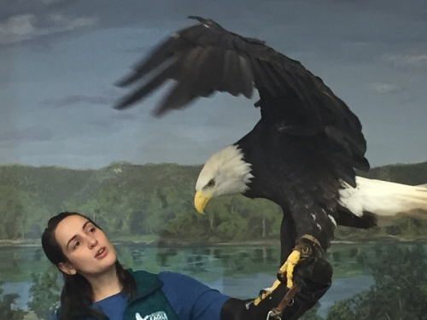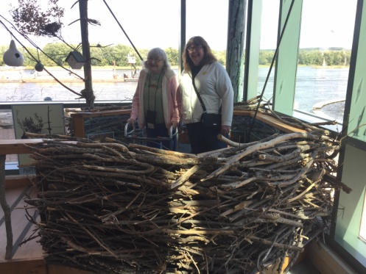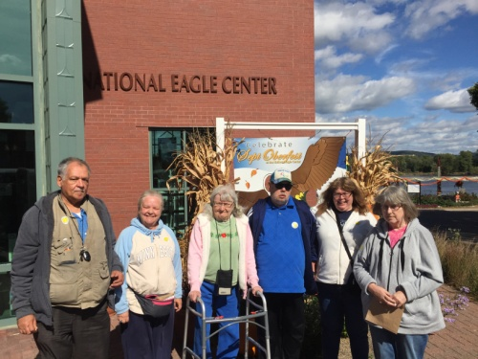

Library lovers for this edition were Marilyn, Rick, Tim and Sam. We are still going to the lovely historical George Latimer library until cooler and snowy weather prevails
.
Our Movie Critic's Corner for September saw Home Again. Those that went to see this sweet comedy were Tim, Kathleen, Dan Z., Luanne and Patricia. They gave it 5 thumbs up!

We had a fun visit from the Jaycees. We had a great ice cream social; chatting and playing bingo. Luanne, Steve, Patricia, Joan, Rick, Carla, Peg, Marilyn, Ronnie, Cheryl, Sam, Lucille, Patty, Wanda, Mike, Kathleen, Johanna and Dan Z. enjoyed time with these volunteers.

Outstanding October

October is such a great month for road trips. One adventure we had was to Pioneer Village in Hastings. Luanne, Carla, Lucille and Kathleen were game for this ride.
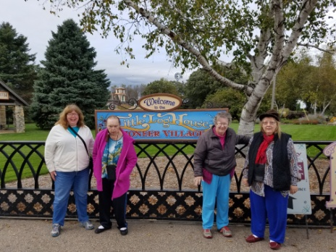

Our Sunday Bingo players for September and October were Dan Z., Ronnie, Johanna, Lucille, Dan J., Kathleen, Patty, Marilyn, and Joan.

It wouldn't be fall if one didn't go to an apple orchard. Aamodt's Apple Farm in Stillwater was a delight! What fun to go on the wagon ride and pet goats. Brian, Kathleen, Patty, Joan and Ronnie went to this fall favorite.

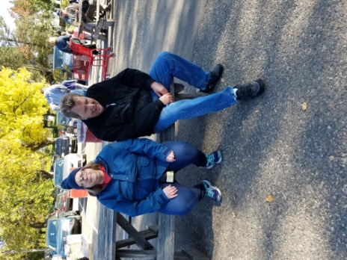

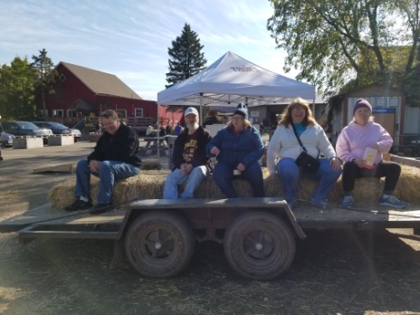

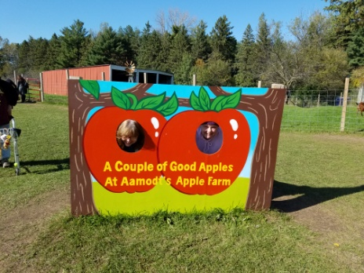
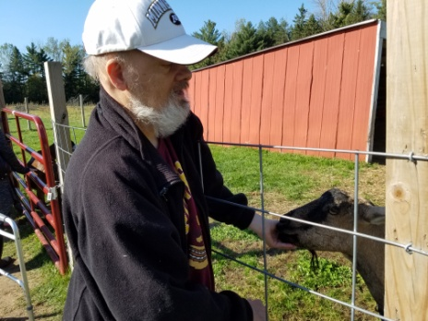

Oh my, five birthdays in October! We started with Luanne. She picked The Great Moon. Patricia, Lucille and Dan Z. enjoyed this Chinese buffet with her. Rose picked KFC and those who celebrated with her were Joan and Carla. Johanna, Mike, Brian, Marilyn, Patty, Tim joined Kathleen at Golden Corral for her day. Steve picked IHOP. Peg, Wanda and Sam went to the International House of Pancakes with Steve.

Many participated in creating faces for the two pumpkins that were to be carved. We chose the two designs in an anonymous drawing and Patty and Dan J. carved the adorable faces.

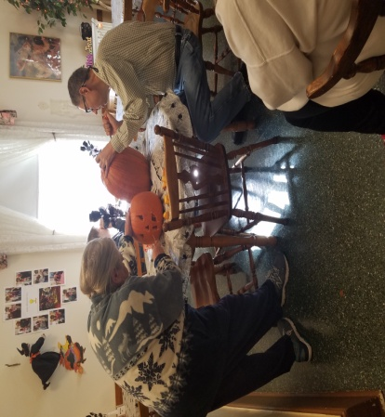
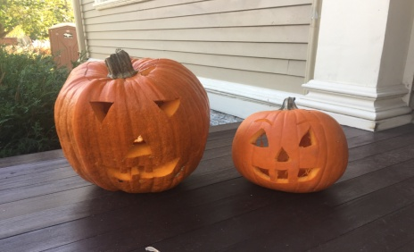
Our Halloween day was hauntingly delicious. We started with lunch and had ghoul-ish. At the party, we enjoyed the pumpkin seeds from our pumpkins. A good game of bat toss in the caldron, place the mole on the witch and pin the tail on the black cat were played.

Our office assistant Rebecca and family came to visit.
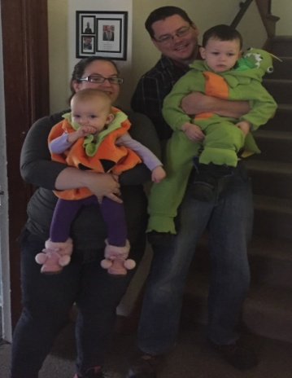

Many went to the famous MCD coffee and soda outing. Getting together for good conversation and a beautiful fall drive were, Patricia, Luanne, Tim, Patty, Peg, Kathleen, Brian, Joan, Mike, Marilyn, Sam, Lucille, Carla, Wanda, Johanna and Dan Z.

September and October shoppers and errand participants may have gone to the following: Target, Pusch Salon, Dollar Tree, Great Clips, Pearle Vision, Walmart, Family Dollar, Cheapo's, Good Will, Post Office, JCP, Harmar Mall and Walgreens . Some of those that went were Luanne, Steve, Patricia, Joan, Lucille, Peg, Patty, Tim, Kathleen, Brian, Marilyn, Dan J., Sam, Wanda, Mike, Johanna, Ronnie and Dan Z.

Inspirational Thought
Those who thank God much are the truly wealthy. So our inner happiness depends not on what we experience but on the degree of our gratitude (Albert Schweitzer)

Environmental News

Why not share all your left over Halloween candy with the food shelf nearest you, so it can be shared with those less fortunate?

Happy Birthdays

SEPTEMBER
5 - Johanna Vogler makes lovely bulletin boards and likes to make her dresser very pretty in her creative manner.
10 - Brian Farrell is a regular at Bible study as he remembers so much information and is helpful in sharing it with others.
20 - Cheryl Lundgren knows our area by heart as she walks so much and enjoys all the surrounding sights.
OCTOBER
3 - Luanne Christensen is our artist in residence who creates realistic portraits in pastels and frequently plays with her granddaughter.
9 - Rose Lenihan is our cat lover, taking care of one of our dear kitties along with sewing and crocheting lovely items.
16 - Kathleen Rohloff writes to her family in Florida who she enjoys visiting and getting to see parts of Florida.
22 - Lee Lazarich loves going to the Mall of America and checking out the stores and decorations that are there.
31 - Steve D'Agostino is our nature, geography and history buff, besides collecting coins and stamps.

News From Honduras
(from Deysi Blanco)

Thank you very much for the check you sent for our ministries. It was useful for all the activities we had last month. We have a wonderful time in all the communities. We celebrated The Children’s Day. We are glad to know about the group at Amy Johnson Residence. We appreciate the work you are doing in favor of the people. We love all of them. Please receive a warmful hug. The people here are very happy because it is raining a lot. They have planted corn and beans. We hope to have good harvests in this area. We hope to hear from you very soon.

ATTENTION FAMILIES AND FRIENDS

We are again looking at the possibilities of a Family Council made up of relatives and friends of the residents of Amy Johnson Residence. The basic purpose of the council would be for those involved to be more aware of our activities and happenings at Amy Johnson Residence, to makes suggestions to further enhance our home, to continue our caring community and to help share skills with the residents. Eventually this council would be a self running group with liaison to the staff of Amy Residence. If you are interested, please contact Kathy or Devonna at Amy Johnson Residence at 651.227.0574 and leave a message Thanks for your concern.

Roaming Reporter
Wants to Know...

My favorite part of fall is...

Pat - The temperature.
Cheryl - The leaves.
Rick - Deer or duck hunting.
Mike - The leaves changing and the cooler
weather.
Carla - The leaves.
Dan J - The leaves.
Wanda - The leaves.
Patty - The mild weather.
Kathleen - Apple cider and my birthday.
Johanna - Halloween parties.
Joan - Leaves.
Tim - Mild weather.
Peggy - Changing of the trees.
Steve - The cool, crisp evenings.
Ronnie - The gorgeous weather and watching
football.
Sam - The fall of the Roman Empire.
Brian- Watching the Viking.

